Example 1

ACTION PLAN

Summary of Initial Results:

I should start by saying I am really glad that we had this assignment and that my students were given the opportunity to speak freely about how they view my class. Some things that the students rated were what I expected, but several items really shocked and/or upset me. This action plan will break down the initial REACT survey results for each category and state the categories I will work on the most over the remainder of the semester before administering the survey again.

I administered the REACT survey to my first period English IV class, and the results are as follows: Classroom Connectedness (3.64), Differentiated Instruction (3.36), Formative Feedback (3.37), Goal Orientation (3.39), Instructional Presentation (3.40), and Positive Reinforcement/Classroom Management (3.41). The scores ranged from 3.36-3.64, and the average score was 3.42. My highest score was for “Classroom Connectedness” and my lowest score was for “Differentiated Instruction.”
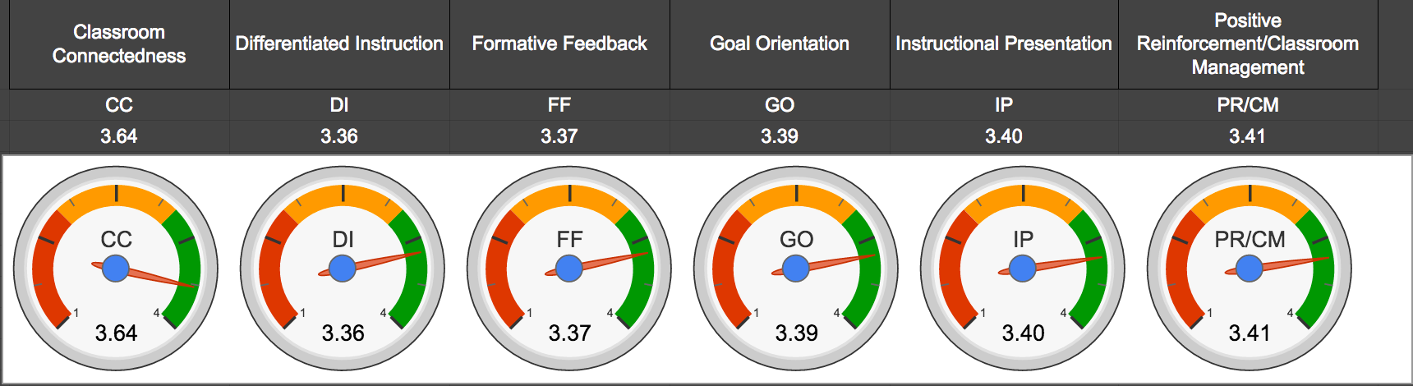

Synthesis of Results:

In terms of Classroom Connectedness, I feel confident that I have started a positive learning environment for my students this year, and it seems like the students would agree. I have put a lot of work and thought into making my class enjoyable and being a teacher that my students can trust, so it is good to see that the majority of my students would agree. I am troubled by the 2-3 students who say they feel disrespected by me or that I stay upset with them, but I am hoping that these results can be improved as the year goes on and the students see that I am always on their side and trying to help them to succeed and graduate.

For Differentiated Instruction, this is definitely an area in which I struggle, mostly because of the curriculum map that the English IV teachers use at my school. The majority of my classes complain about the ONE homework assignment I give all week (vocabulary), and I am considering trying a different vocabulary method next year; however, I want to give it a full year try before giving up on it since it is the method that the other two English IV teachers use. I feel like the texts we use are very rigorous, maybe too rigorous for our students’ level; however, the administration is really pushing our grade level in terms of text rigor, so I am not sure how much of that I can change.
In terms of formative feedback, some of the students’ responses confuse me like “it takes a long time to get our work back in class.” I give almost every assignment back, graded, within one or two days, and all assignments (barring essays) are graded and grades are inputted online (where the students can see their grades) on the SAME DAY that I collect them. So that one just does not make sense to me. But providing information on how to correct mistakes (especially with writing) and explaining how each student is doing in my class are the two small sub-areas that I really want to improve on for the remainder of the semester.

For Goal Orientation, the two parts that I got the most negative results are “my teacher sets goals for our learning when we start a new activity or lesson” and “my teacher helps me make plans for how I will do my work.” For the first, I guess I thought I was already doing that when I set the agenda for the day and the week, and I set time goals for each class period. So I wish I could have a few students give me suggestions for how this could work better in our classroom. On the second, I wonder if the students interpreted this in terms of in-class activities, projects, or essays. I can see why they would think I do not help them make plans for projects because once I give them a rubric and a sample, I expect seniors in high school to be able to manage their own time and set their own plans and goals to get work done.

For Instructional Practice, the worst results were for the following sections: “we always review the key points of the lesson before class ends” and “we practice with our teacher before we work on our own.” These two areas I definitely need to work on, and I knew that I did before the survey even went out. These two parts of my lesson are definitely lacking, and some of that comes from rushing in my lessons and running out of time at the end. I find that the amount of activities/material that the curriculum maps suggest we get through each day is too much, and I envy some of the other MTC teachers who are getting to create their own lesson plans. I feel like I am constantly rushing to get everything in the lesson plan done and stay on track with the other English IV teachers in terms of pacing that I do not find the time in each lesson to review at the end and to do the shared practice before my students either work independently or in groups, and the results from this section indicate that the students would agree with this assessment.

For the results for Positive Reinforcement/Classroom Management, I am honestly upset by the results on two of the sections: “students pick on each other in class” and “sometimes I am distracted by other students in class.” To have 4-5 students answer “mostly negative” on those is upsetting because even one student feeling that way is not the way I want my classroom to be. I always wanted to have a classroom where students feel safe and comfortable, and it is upsetting to see 4-5 students remark that they are being picked on and/or distracted by other students. Classroom management, as always, is a major focus for me, especially as a first year teacher, but clearly I am not succeeding in this area as much as I would like to be at this point in the year.

Plan Based on Results:

The first thing that I want to work on is in Formative Feedback, and I will hopefully accomplish this on their next major essay assignment. I am planning on going through each essay and grading it for grammar, composition, organization, and content, then giving it back to the students without a final grade on it. Then, the students will have the opportunity to make corrections, come to me for help on the essay, and turn it back in to be actually graded in the gradebook. I am hoping that by doing this we can talk through some of the common errors and they can get feedback on their writing. I also want to start providing mini oral progress reports to students, especially those who are missing a lot of assignments and their grades are low. This can be done with an extra minute or two at the end of the class by just calling a couple students back to my desk one at a time to look at their current grade and make a list of missing assignments that they can make up.

The second thing I will work on is for Goal Orientation, yet the results for this section are some of the most difficult to change, in my opinion. But I think this section of the survey helped me to see that my students might want a little more help in organizing their time and helping them get a plan ready to tackle classroom activities and also for individual work, and that is something I want to work on as the semester progresses. Especially for project work, I want to add not only more reminders as to due dates, but maybe break the project up into parts and remind the students to have certain parts done on certain days so that by the due date, their projects should be complete.

The third thing I will work on is for Instructional Practice, and for this I will try to start carving out the time for reviewing the lesson at the end of each period and practicing with the class as a group before moving on to individual practice. Both of these strategies I just have to make happen because both are important to the students’ learning. Both of these things I am going to try to do from now on and just know that it is okay if we do not get through all of a worksheet/activity — that it is more important for me to take the time to do some of it with them and to review at the end of each lesson that to “get through it” completely.

The final thing I hope to accomplish falls under the Positive Reinforcement/Classroom Management section of the survey, and with this I want to try to be more vigilant about students picking on one another. As for students being distracted by other students, I can see that being an issue for all of my classes. We have some “class clown” situations in almost every class, and it is difficult to manage that one student, let alone the whole class day after day. My goal is to work on isolating those students around the room and making sure that they get my attention, not the attention of the other students, so that they do not distract the whole class. I am planning on implementing more “helper” roles for these students, too, so they stay too busy helping me and doing their work to “cut up.”

FINAL REPORT

Summary of the First and Second Survey Results:

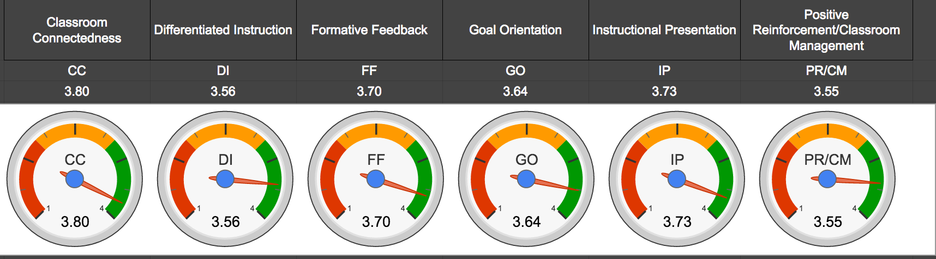
I was very pleased when I received the results of the second survey administered to the same class period and I saw that my scores went up in all six categories, even the ones that I was not actively trying to improve over the past few months. I can honestly say that the results reveal the work I put in to making my classes better during the second half of this semester. I actively tried to improve on Formative Feedback, Goal Orientation, Instructional Presentation and Positive Reinforcement/Classroom Management (see goals/improvement strategies in above section), and the results from the second survey suggest that my strategies worked on at least some level. The summary of the result changes for the first and second survey are as follows: Classroom Connectedness (3.64 to 3.80: .16 increase), Differentiated Instruction (3.36 to 3.56: .20 increase), Formative Feedback (3.37 to 3.70: .33 increase), Goal Orientation (3.39 to 3.64: .25 increase), Instructional Presentation (3.40 to 3.73: .33 increase), Positive Reinforcement/Classroom Management (3.41 to 3.55: .14 increase).

Comparison of Results:

For Classroom Connectedness, I am not exactly sure what specifically I did to improve my score, but I do think that like in “Instructional Practice” below, increasing the “buy in” to my class seems to have done wonders. Part of this I believe has been achieved by trying to just be more relatable to the students. I think they are starting to finally believe that I am not being mean and assigning them work just for the fun of it, but that I am doing it for a purpose. I have also tried to take time to work with more of my IEP students one on one (even if it is just kneeling down and making sure they understand the directions completely), and I think this has helped them to feel like I am truly on their side, which I am. In some of my assessments from the first survey, I noted that I thought those sections would improve with time, and I think this is one of the sections where the students just had to see me caring about them day in and day out for them to finally believe in me as their teacher.

In terms of Differentiated Instruction, I realized that there was not much I could do about the level of difficulty of the texts that I was required to use in my classroom, but what I could do was to try to make each text as exciting and relatable to my students as possible. No doubt any teacher would struggle to make Beowulf relatable to high school students in this day and age, but I have definitely started to let my inner nerd come out in my teaching and show the kids that it is okay to just get excited about literature (even Beowulf!). Does this always work with my students? Absolutely not. But I have seen that although I can not change the curriculum map, I can help my students “buy in” to the literature thought my excitement and through building it up with what I refer to as “hype videos” for new units. Students have a hard time not watching any time of video that you show in class, so I use this interest in digital media to try to get my students engaged in whatever literature we are tackling next. I am already looking for a good hype video for Macbeth next semester!

For Formative Feedback and Instructional Practice, these were the two areas in which I showed the most growth from the first survey to the second survey (both equally at a .33 increase). For Formative Feedback, and this will probably sound terrible, but I just kind compared my efforts at giving them feedback in a timely manner with efforts of other teachers. I think putting this in perspective for my students helped them to see how hard I was working to get them feedback as quickly as possible and with as much detail as possible on items such as essays, discussion questions, etc. I also implemented the plan as described above where I completely edited their essays and then gave them back to work on them again, implementing my feedback, before turning in as a final grade. When I was handed back the initial essays with my corrections/suggestions, I did a general survey of hands as to if they had had other teachers try this on their writing before, and the general results were that they could only improve from one essay to the next, not improve on the same essay (multiple drafts). So I think that having that discussion with them and the actual practice of allowing them to see teacher feedback and then have the opportunity to improve on the same essay was a good way to improve the formative feedback in my classroom. I also hope that this experience helped them overall in their writing, and that the next essay I assign the students will implement some of the same feedback into more mature writing.

In terms of Goal Orientation, mostly I just began adjusting the way I set goals for bigger projects. I think my students were already aware of my goals for our class as a whole and somewhat for day to day instruction, but where I think I have improved on this section is breaking down projects (test grades) into more manageable “chunks” and by making sure that my samples of the projects are attainable models for my students. In doing this, I have had better participation in projects, which can be see from the amount of projects turned in now as compared to the beginning of the year. I worked on making my rubrics more explicit and by showing how many points each factor is worth. I think for my students it is important for them to not be overwhelmed by the amount of work that I will expect from them on any given assignment. I remember being their age and being overwhelmed by larger projects (essays, creative work, etc.), so I want to make sure that I make each grade like this feel manageable, and I think I have made this better over the past month a half by just breaking down the projects into more attainable segments.

For Instructional Practice, I think that two factors are at play in making this one of the two areas in which I showed the most growth: first, the fact that I am just more confident in myself as a teacher, and, second, I am starting to get better at “reading” the students and knowing how to reach them more effectively now that I just know them better. I feel like in the last month and a half I have increased the “buy in” of my students to my class, and that is a major contributing factor to them being more receptive of my instructional presentation. I have specifically tried to increase the “I do” at the beginning of practice before “we do” or “you do,” and I think that the students have responded to this by being more confident in their individual practice. I have also done better at “wrapping up” a lesson at the end of each class period so that the students can feel the advancement made by each class period. I am aware that these two strategies seem obvious, and that both of these strategies were encouraged this summer at Holly Springs, but I guess it took me reading my students’ comments from the first survey to understand just how important these parts are to every lesson.

Finally, for Positive Reinforcement/Classroom Management, I think I improved more than my score reflects on this section, but any improvement is pleasing to me for this category because I know how much I still struggle with this. Since joining my school’s PBIS Team a couple of months ago, I have seen the benefits of positive reinforcement on a school-wide level, and that has made it more of a priority for me to implement in my own classroom. I rely too heavily on my marble jar to be an incentive for my students because some students just do not care about ruining it for the whole class, so I would still like to develop different ways of rewarding individual students. I said I was going to do several things at the beginning of the year that would be more individual behavioral incentives, and I have kind of dropped the ball on these, but I think starting these after Christmas break would be a good transition into reminding my students about the importance of their individual work ethic. One thing I am going to try is a homework corner raffle (anyone who turns in complete homework can put their name on the corner of their homework, tear it off, and put it in a bucket to be drawn at the end of the week for a prize). Although it hard for me to conceptualize rewarding students for behavior that I want them to innately maintain, I recognize that little incentives like this generally provide good results, and I will try anything to get my students to try!

Reflection on REACT:

Overall, I was extremely pleased with the changes in my results on the REACT survey from the first administration of the survey to the second administration. Getting to know what my students think of my class, as opposed to a fellow teacher or administrator, really helped me know what to focus on in terms of making positive changes for my classroom. I found that some things that I did not think I was doing well with (Formative Feedback) I am actually doing pretty okay in, and other things that I thought I was doing well in (Positive Reinforcement/Classroom Management) could actually use improvement, and all of my information came “straight from the horse’s mouth,” so to speak. As always, I am a lot harder on myself than I probably should be, and I should, in actuality, be very pleased with having such high scores from my students during my very first year of teaching. It would be interesting to me to have my same class take this survey at the end of the year to see if they think I have made any additional improvements from now until then. I feel as though this would really bookend the first year of teaching with my very first class!

